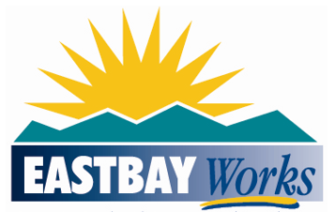
Public Notice

Contra Costa County Workforce Development Board
and EASTBAYWorks Regional Planning Unit
Workforce Development Plans for Program Years 2021-2024

Contra Costa County Workforce Development Board and the EASTBAYWorks Regional Planning Unit will be submitting their Workforce Development Plans for Program Years 2021 through 2024 to the Governor’s Workforce Development Board as of April 28, 2021.

As outlined in the Workforce Innovation and Opportunity Act (WIOA) Section 108, Local Plans provide an action plan for operationalizing the road map laid out in the Regional Plan by describing how individuals’ access services through the America’s Job Centers of CaliforniaSM (AJCC) system. Local Plans are used to articulate how Local Boards will coordinate with local partners to ensure a person-centered service-delivery.

Contra Costa County Workforce Development Board’s Local Plan will be available for its 30-day public review and comments (March 23, 2021 through April 23, 2021). Interested parties may submit comments regarding the proposed Local Plan to Contra Costa County Workforce Development Board at: WDB@ehsd.cccounty.us

*****************************************************************************************************************

The East Bay Regional Planning Unit (EBRPU) is pleased to release the Draft 2021–2024 Regional Plan for 30-day public comment ending April 19, 2021.

The State of California Workforce Development Board requires regions to create new Regional Plans every four years. The EBRPU comprises the four East Bay Workforce Development Boards serving Alameda and Contra Costa Counties and the Cities of Oakland and Richmond.

Developed with input from partners and stakeholder, the regional plan describes goals and strategies for building regionally coordinated workforce services to meet the needs of employers and job seekers anchored by equity and inclusion.

The East Bay Regional Planning Unit, Regional Plan and online comment forms can be found on the EASTBAYWorks website at: Regional Plan page. Interested parties may send comments directly to: regionalplancommentebrpu@gmail.com

